**STRONGER**

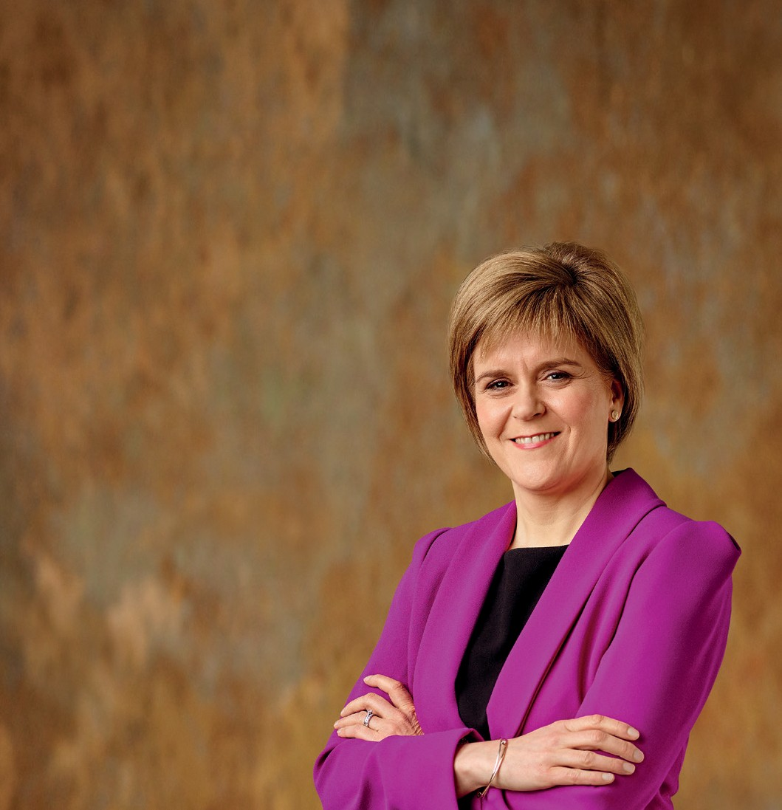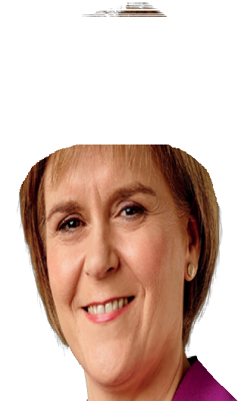

**FOR SCOTLAND**

**Manifesto 2015**

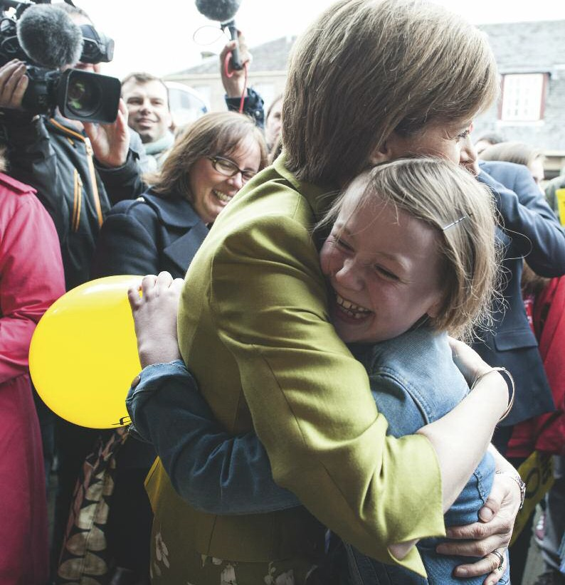

Nicola Sturgeon - pictured here embracing a young supporter on the general election trail - has pledged to be the most accessible first minister ever. The SNP leader stands out in personally engaging with people on social media and during campaign events. She’s a regular tweeter and can be found at @NicolaSturgeon

**My vow is to make Scotland stronger at Westminster.**

At this election, we have the opportunity to shake up the out of touch Westminster system so that it serves Scotland better.

A vote for the SNP on May :th is a vote for MPs who will always stand up for Scotland's best interests.

It is a vote to make Scotland's voice heard at Westminster more loudly than it has ever been heard before. And it is a vote for more progressive politics.

The SNP will use our influence at Westminster to help deliver positive change for the benefit of ordinary people, not just in Scotland, but across the UK.

We propose a real alternative to the pain of austerity,

an end to unfair policies like the Bedroom Tax, a higher minimum wage and protection for our NHS and vital public services.

Instead of even deeper Westminster spending cuts, we want to see more investment in our economy, to create more and better paid jobs.

And we want the precious resources of our country to be invested in building a better future for our children, not on a new generation of nuclear weapons.

The SNP will never put the Tories into power.

Instead, if there is an anti-Tory majority after the election, we will offer to work with other parties to

keep the Tories out.

And we will then use our influence to demand that Labour delivers the real change that people want and need - instead of just being a carbon copy of the Tories.

A vote for the SNP will make Scotland's voice heard - loudly and clearly.

And it will help deliver new, better and more progressive politics at Westminster for everyone.

My vow is to make Scotland stronger at Westminster. With your support, we can secure a better future for you, your family and Scotland.

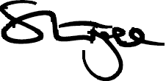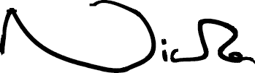

03

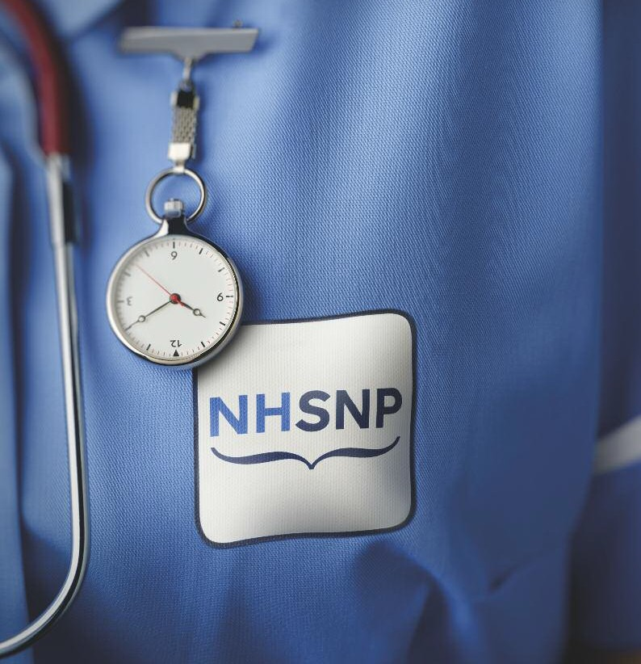

**WHO CARES**

**MOST FOR**

**OUR HEALTH SERVICE?**

**Everyone agrees Westminster needs to change. The SNP is ready to play a constructive role,**

**to challenge the old order with new and progressive ideas.**

**It’s time to put fairness and equality back at the heart of government.**

**With a strong SNP team at Westminster we can use our influence to end the needless pain of Tory cuts. And we can campaign to secure more money for health, education and childcare.**

**Here are our key priorities to make Scotland stronger at Westminster:**

An end to austerity

SNP MPs will demand an end to austerity. We oppose further spending cuts and propose modest spending increases - of

0.5 per cent above inflation - in each year of the next Parliament.

Under our plan, the deficit will still reduce each year, but there will be at least an additional £140 billion across the UK to invest in skills and infrastructure, in our NHS and other public

services, and in measures to protect the vulnerable and lift people out of poverty.

We will also vote for the following revenue raising measures - the reintroduction of the 50 pence top tax rate, a tax on bankers' bonuses, a bank levy, a mansion tax, a crackdown on tax avoidance, the abolition of 'non-dom' status and reversal of the married couple’s tax allowance.

Increased NHS funding

We will meet the NHS funding challenge laid down in the report of the NHS Chief Executive in England – the Stevens Report - and vote for an increase in NHS spending across

the UK of £24 billion by 2020-21 - £9.5 billion above inflation.

This will deliver a total boost to the NHS Scotland budget of £2 billion by 2020-21.

SNP MPs will also vote against any further privatisation of the NHS in England and back any moves to restore it to a fully public service.

Continues on page g

**Opposite:** The future of Scotland’s NHS is at the heart of the general election with SNP calls for

an extra £2 billion for the health budget. 05

Fairer pensions

We will support a single-tier pension of £160 per week and vote to continue the triple lock, guaranteeing that pensions will always rise by inflation, earnings or 2.5 per cent - whichever is the highest. We will also vote to protect the Winter Fuel Allowance.

We will oppose the abolition of Savings Credit – introduced to reward people for saving for their pension - and we will seek a review of plans to increase the state pension age beyond 66.

Scrapping Trident

We will oppose plans for a new generation of Trident nuclear weapons and seek to build an alliance in the House of Commons against Trident renewal. We will vote for the £100 billion that the Westminster parties plan to spend on Trident renewal to be invested instead in better childcare, education and the NHS.

Better paid jobs

We will vote to increase the minimum wage to £8.70 by

2020. We will also support measures to extend the Living Wage across the UK. The Scottish Government already pays the Living Wage to all of its own employees and to those covered by its pay policy - we will call on, and vote for,

the UK government to adopt the same policy.

Reducing child poverty

It is estimated that an additional one million children across the UK will be living in poverty by 2020. That is unacceptable and would mean an additional 100,000 children in Scotland growing up in poverty.

That is why we will vigorously oppose plans for further cuts in Child Benefit and Tax Credits - allowing these payments

to erode in value simply pushes more children into poverty.

Instead, we will vote to increase benefits at least in line with CPI inflation, to ensure that the incomes of the poorest in society do not fall even further behind the cost of living.

And we will support an increase in free childcare to 30 hours per week by 2020.

More support for disabled people and carers

We will vote to block plans to cut Disability Living Allowance by £3 billion across the UK by 2017-18. Scotland’s share

of that cut is around £310 million per year.

These cuts would see more than 100,000 disabled people in Scotland – and one million across the UK – losing over

£1,100 a year in the support that they rely on to live independent lives. We will use our influence to make sure that these cuts do not proceed and that disabled people are given the support they deserve.

We will also support an increase in Carer’s Allowance so that it matches Jobseekers' Allowance. Those in receipt of Carer’s Allowance will benefit by almost £600 per year.

08

Scrapping the Bedroom Tax

We will vote for the immediate abolition of the unfair Bedroom Tax. Abolishing the Bedroom Tax would mean that the £35 million a year that the Scottish Government is spending to compensate those affected by it would be

available to spend on other priorities. We would invest that money in measures to tackle - and eventually eradicate - food poverty.

Investing in education

We will guarantee the continuation of free university education in Scotland and support the reduction of tuition fees across the UK.

We will extend the availability of Educational Maintenance Allowance in Scotland to an additional 10,000 school pupils and 12,000 part time college students.

Opposing withdrawal from the European Union

At least 330,000 Scottish jobs – around one in seven of

all jobs - are dependent on our membership of the single market. That is why we will oppose a referendum on membership of the EU. Being part of Europe is good for business and it supports jobs in Scotland and across the UK.

If an in/out EU referendum does go ahead, we will seek to amend the legislation to ensure that no constituent part of the UK can be taken out of the EU against its will. We will propose a 'double majority' rule - meaning that unless England, Scotland, Wales and Northern Ireland each vote to leave the EU, the UK would remain a member state.

Immigration policy that works for Scotland Diversity is one of Scotland's great strengths. Effective immigration controls are important, but we must also remember that those who have come to Scotland from other countries make a significant contribution to our economy and our society.

We will support sensible immigration policies that meet our economic needs and, as a priority, we will seek the reintroduction of the post study work visa, so that those we have helped educate are able, if they so choose,

to make a contribution to our economy.

More affordable housing

There is a substantial shortfall of affordable houses for rent across the UK.

The Scottish Government is on track to meet the commitment to 30,000 new affordable homes by 2016, but more needs to be done. We will back investment in an annual house building target across the UK of 100,000 affordable homes a year.

We will also continue our support for Help to Buy and shared equity to help people get a foot on the housing ladder.

A focus on job creation

We will support targeted reductions to employer’s National Insurance contributions to support job creation and the extension of the Living Wage.

We will support an increase in the Employment Allowance from £2,000 per business per year to £6,000 per business per year, reducing the cost of creating and maintaining jobs.

09

We will support this change being phased in over the four-year period to 2019-20.

Fair work

In-work poverty is a modern day scandal that must be tackled. We support increases in the personal tax allowance but will also back an increase in the Work Allowance – the amount people are allowed to earn before their benefit is cut – of 20 per cent. This will encourage people back into

work by reducing the amount the state claws back – making work pay more.

We will also support tough action to end exploitative zero hours contracts.

Action on energy bills

We will support lower energy bills for consumers by pushing for the Energy Company Obligation to be funded through general taxation and not as a levy on energy bills. We will

also support new powers to make sure that energy companies pass on the benefits of lower prices to consumers.

We will also press for a change to the transmission charging system that is penalising Scottish generators and threatening the future of Longannet power station.

Greater care for our environment

We will call on, and vote for, the UK Government to adopt

Scotland’s ambitious carbon reduction targets.

We will also continue to support a moratorium on fracking.

Ensuring equality

We believe that women should be properly represented in public life. We will push for 50:50 representation on public and private boards, and ensure that women are fairly treated at work with action to secure equal pay and greater support for working parents with increased paternity leave.

Democratic reform

Westminster badly needs to be reformed. An unelected second chamber is not acceptable in a modern democracy. Those with no democratic mandate should not be writing the laws of the land and SNP MPs will vote for the abolition of the House of Lords.

We will also vote for the replacement of the first past the post voting system with proportional representation.

Delivering Home Rule for Scotland

The SNP will always support independence - but that is not what this election is about. It is about making Scotland stronger.

We will use the influence of SNP votes at Westminster to ensure that promises made during the referendum are delivered.

We will demand, firstly, that the proposals of the Smith

Commission are delivered quickly and in full.

We believe that these proposals do not go far enough to honour the promises made during the referendum.

10

We will seek agreement that the Scottish Parliament should move to full financial responsibility.

As implementation of the Calman Commission proposals has demonstrated, the transition to full fiscal responsibility - and agreement of the detailed fiscal framework that would underpin it - would take a number of years. SNP MPs will work to secure the best deal for Scotland.

In the meantime, we will prioritise devolution of powers over employment policy, including the minimum wage, welfare, business taxes, national insurance and equality policy - the powers we need to create jobs, grow revenues and lift people out of poverty.

An end to Tory government

If there is an anti-Tory majority in the House of Commons, we will vote in a motion of confidence against a Tory government getting off the ground.

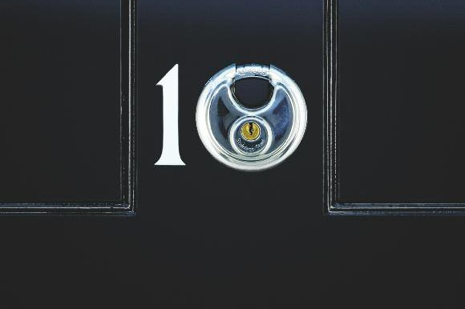

The SNP is offering to work with other parties to lock the Tories out of Downing Street and bring an end to the needless pain of Tory cuts.

**LET’S LOCK OUT THE TORIES.**

**The SNP is the third largest party in the UK following a surge in new members since the referendum. 8j,jjj have joined since September 2j14, with total membership now over 1j5,jjj. The SNP’s 5Y candidates includes prominent Yes campaigners and others who have only just joined**

**the party. Here are some of their stories:**

Mhairi Black

One of the consistent features that I have witnessed growing up has been the level of poverty and injustice that ordinary people are forced to endure.

Westminster has continually let us down. I truly believe that the only way to bring the powers we were promised, and the social justice that Scotland so desperately needs, is to have a strong group of SNP MPs at Westminster to

ensure our voices are heard.

Michelle Thomson

My background is not in politics but in business. However, I believe we need fundamental change at Westminster and I want to help shape that change. Let's end the old Westminster way of doing things, which has caused misery for Scotland's most vulnerable. We have

the opportunity to chart a different economic path - one which benefits the whole of society. Scotland's voice

can and must be heard.

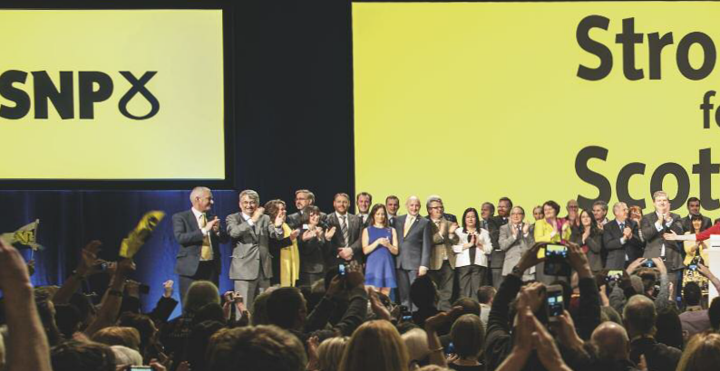

**Main photo:** Nicola Sturgeon introduces candidates to the SNP's biggest ever conference in

12 March 2015, with over 3,000 people attending the two-day event in Glasgow.

Tasmina Ahmed-Sheikh

As a mother of four, I believe our young people are Scotland's greatest resource but poverty is damaging the potential

of too many of them. Hope for the future must be matched by the ambitions of

our elected representatives. We must work to build communities that offer the next generation the best possible start in life. That’s why we need an end to Tory and Labour cuts. The SNP provides a

real alternative to that Westminster

austerity consensus.

Tommy Sheppard

I was a Labour member for 20 years

and like many former Labour supporters, I've joined the SNP because I believe it's now the best way to build a better, fairer country in Scotland. The more SNP seats we have, the more we can force Labour to be different from the Tories. That's a lot better than leaving them to their

own devices.

Philippa Whitford

I know how precious the NHS is through my work as a consultant breast cancer surgeon. That’s why I am taking a stand to protect Scotland's NHS from the privatisation agenda of the Westminster parties. To tackle the poverty which underlies much of our ill health, SNP MPs will oppose further austerity cuts and seek the powers to set a decent minimum wage and protect

our vulnerable citizens.

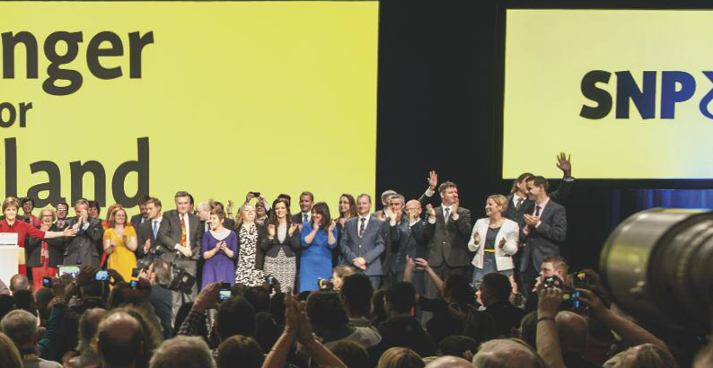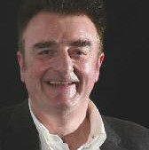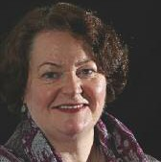

13

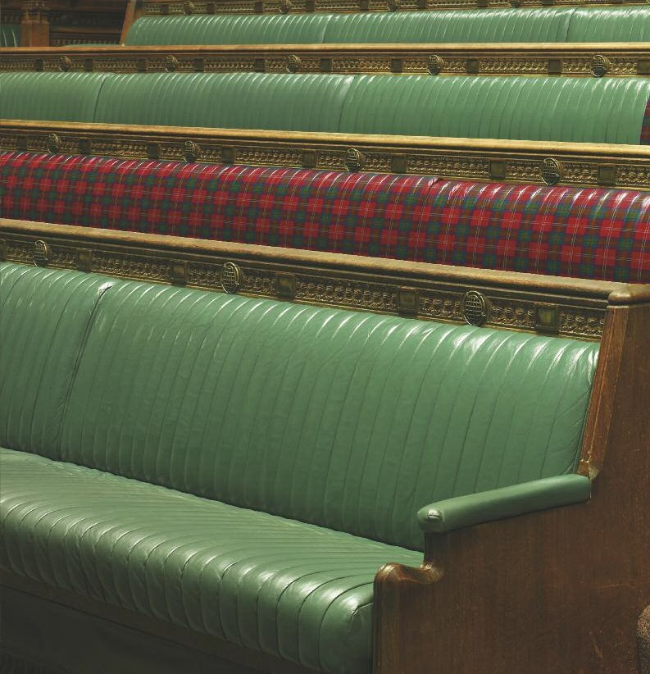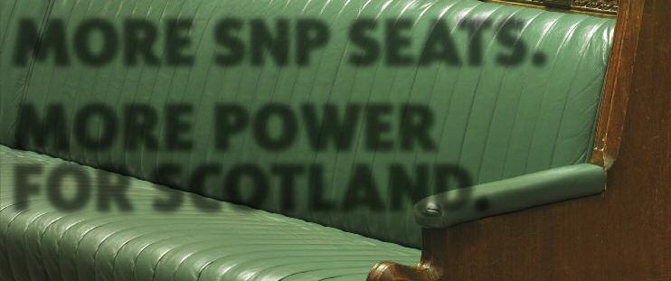

**MORE SNP SEATS.**

**MORE POWER FOR SCOTLAND.**

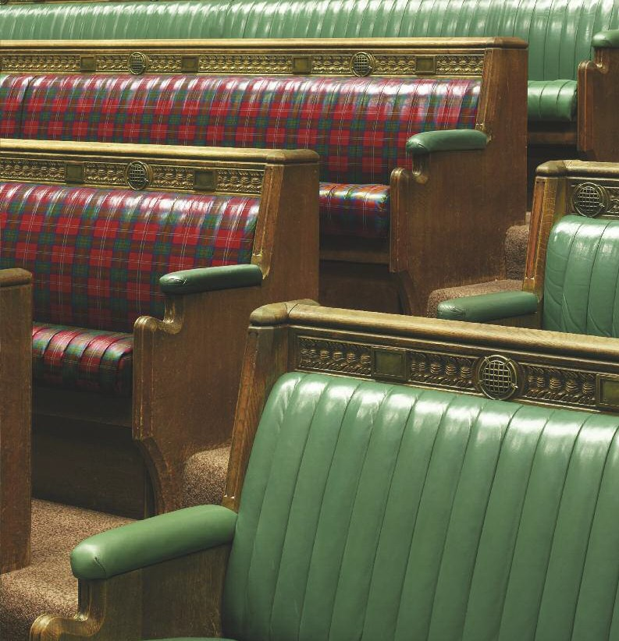

Available in Audio, Large Print, Braille and Easy Read formats.

Please call 0131 525 8903.

•

'

i

i

• i I

i

'

:

•

!

f



j

**0Vote SNPlS** !

Polls on 7am - lOpm Thursday 7May ;

i

t

! f l

**MANIFESTO**

**FOR A**

**STRONGER SCOTLAND.**

**Manifesto 2015**

PRIORITIES FOR A FAIRER AND MORE SUCCESSFUL SCOTLAND

Whether in Scotland or at Westminster, our focus will be on growing Scotland’s economy and making life

better for people across our country. This is what underpins our policies on public finances, on education, health, housing and social justice and our support for the Scottish Parliament having more of the powers it needs. We want more people in rewarding, well paid work. We want stronger local economies, with job opportunities

for our young people close to home so we can retain

the important links of family and community that add to the strength and well-being of our society.

But this is not economic growth for its own sake. It must be sustainable and with the benefits shared across society. It will be wealth creation so we can, once and for all, address the unacceptable levels of inequality in Scottish society. As we set out in this manifesto, we will be able to build Scotland’s success and deliver on our ambitions by harnessing the energy of our people, by building our skills and using them to the full, and by making the most of our nation’s great natural wealth

and many competitive and comparative advantages.

The more SNP MPs that are elected to Westminster, the louder Scotland's voice will be in the decisions that are taken there - and that means we can secure the best deal for Scotland and a more progressive approach for the benefit of people across the UK. SNP MPs, backed by hundreds of thousands of new supporters - many voting SNP at Westminster for the very first time - can

make a real difference to the direction our country takes in the years ahead.

With greater influence for Scotland at Westminster and new powers for our parliament in Edinburgh, there is so much more we can achieve for the people of Scotland. SNP MPs will:

Make sure Westminster works better for the people of Scotland

**•** The biggest threat to Scotland’s public services and

our social fabric is the ongoing Tory and Labour obsession with austerity cuts to vital public spending. That is why we propose responsible increases in public spending.

**•** We will support increases in infrastructure

investment as part of our plans to generate new jobs and support higher levels of growth, and we will work to open access to finances for businesses

looking to expand.

**•** Our approach is to secure a fair deal for all with those on the very highest incomes contributing a little bit more to ensure that we can continue to deliver universal, free public services and protect the most vulnerable from the impacts of poverty.

Support the Scottish Government

**•** We back the planned expansion of childcare with

30-hours a week of free nursery education for all 3 and 4 year olds and eligible 2 year olds, providing the best possible start in life for younger Scots and

making life easier for their parents.

**•** We support a big increase in NHS spending in Scotland, and across the UK, to enable the Scottish government to continue improving our health service. Our plans will mean £2 billion more for our NHS by

2020-21.

**•** We will also use our votes at Westminster to protect the health service in all parts of the UK from privatisation.

**•** We agree that we need to maximise opportunities for our young people and support an increase to

30,000 Modern Apprenticeships and the expansion of the Education Maintenance Allowance to an extra

22,000 school pupils and students.

An approach to the public finances that works

We will:

**•** Propose different choices on spending so we can protect fundamental public services and ensure irreparable damage isn’t done to the fabric of society. This will allow modest increases in public spending in each year of the next parliament – it will also see deficit fall every year as a share

of income.

**•** Argue for a fairer approach on taxation, with those with the very most contributing a little bit more

**•** Focus on investment to support economic

growth and the creation of a more productive, high-skill, high-wage economy

**•** Seek to enshrine in law key principles of future

financial management, including elimination of the deficit and balanced ‘current account’ spending by stimulating growth in the economy, as part of a medium term strategy to ensure prudent levels of debt are achieved

**•** Support the creation of a sovereign wealth fund

so that we create a financial buffer for the future, protecting public finances in times of crisis

BETTER OFF WITH THE SNP

We are working hard to make life better for people across Scottish society and the plans we set out in this manifesto will see some new and important gains.

**•** For our NHS – we’ll support a funding package for

the NHS, that would see spending in Scotland rise by a total of £2 billion by 2020-21, helping us to deliver the world-class care that people in Scotland rightly expect.

**•** For fair pay – we’ll back an increase in the minimum

wage to £8.70 by 2020, making a quarter of a million people in Scotland better off by up to £4,000 a year.

**•** For hard-pressed households – we will support

lower energy bills for consumers by pushing for the Energy Company Obligation (ECO) to be funded through general taxation and tough new powers to make sure energy companies pass on lower energy prices to consumers, saving households around £100 on energy bills based on recent wholesale prices.

**•** For more jobs and growing businesses – we will

seek seed-fund capitalisation of the Scottish Business Development Bank, enabling new investment in Scottish business growth and innovation, helping create thousands of new jobs

**•** For people approaching retirement – we’ll seek a

review of the planned increase in the retirement age from 66 to 67, so that people in Scotland, who have paid in to a state pension all their lives, don’t lose out.

**•** For people moving into work – we’ll vote for an

increase in the work allowance by 20 per cent, which means people moving in to work from benefits will keep more of their income.

**•** For unpaid carers – we propose an increase in carer’s

allowance to bring it in line with jobseeker’s allowance, which will see over 100,000 unpaid carers in Scotland better off by almost £600 a year.

**•** For pensioners – we want a single-tier pension set at

£160 per week, with the triple-lock protection continuing. This will guarantee that the value of the state pension is fully protected.

**•** For no new nuclear weapons – we continue to

oppose nuclear weapons and will seek to block a new generation of nuclear weapons, saving as much as £4 billion a year in the mid-2020s.

**•** For a greener Scotland – we will continue to support

a moratorium on fracking.

**•** For our veterans – we believe that those who have been injured in the service of our country should get the full value of any war disablement pension and we will work to ensure that it is not treated as income in the assessment of entitlement to other benefits.

**•** For our cities – we believe that City Deals should be

made available to all Scotland’s cities, in addition to Glasgow, bringing substantial new investment to places that are key drivers of growth in Scotland.

**•** For our farming community – we will look to secure

a fair share of the UK’s CAP convergence uplift, which comes to the UK as a result of Scotland’s low hectare rates.

**•** For workers in the oil & gas sector – we’ll keep the

pressure on the UK Treasury to do all it can to protect jobs and investment in the oil and gas industry in light of lower global oil prices and will work to increase internationalisation opportunities for Scotland’s oil

and gas industry

**•** For a fairer Scotland – we’ll prioritise the immediate scrapping of the Bedroom Tax and a halt to the roll out of Universal Credit and PIP. We’ll seek to reverse the replacement of Disability Living Allowance by PIP and oppose the £3 billion cut in disability funding. In addition, we will seek an urgent reform of the conditionality and sanctions regime, to establish a fairer approach.

**•** For Scotland’s creative sector – we’ll seek increased investment through BBC Scotland so that a fairer share of the licence fee is spent in Scotland, giving a

£100 million boost to our creative sector.

**•** For local job creators – we will continue the Small Business Bonus and back reduced Employers’ NI contributions to support job creation.

**•** For greater equality - we will demand early action

on equal pay audits for big companies to increase the pressure to deliver equal pay for women across the UK. We'll also support the abolition of VAT on sanitary products.

**•** For young Scots – we’ll deliver 30,000 Modern

Apprenticeships each year and continue to keep university education free. We will also back an increase in the minimum wage rate for 18 to 21 year olds to £6.86 by 2020 and believe the same rate

should be paid to apprentices. We will also support an increase in the rate for 16 to 18 year olds to £5.07.

**•** For our planet - we will use our influence at

Westminster to ensure the UK matches, and supports, Scotland’s ambitious commitments to carbon reduction.

**•** For future generations – we should have greater

financial security in the years ahead and so will call for a share of future revenues from our natural energy resources to be saved in an energy fund.

**•** For low-income households – we’ll back an increase

of at least the cost of living in welfare benefits, such as child benefit, universal credit and disability benefits, and also in tax credits.

**•** For an end to Tory rule – if there are more anti-Tory MPs than Tory MPs in the House of Commons the only way the Conservatives get back in to government is if the Labour party let them. The SNP will work with others to lock the Tories out of government.

**•** For safer communities – we’ll continue to deliver

1,000 extra police officers, a policy that has helped deliver record low crime levels in our communities. We’ll also press for the revenue from court fines to be retained in Scotland and for Police Scotland and our Fire and Rescue Service to receive the same VAT exemption as other forces, with the money reinvested in safer communities.

**•** For a new northern focus – we’ll back budget plans

to invest more in the infrastructure of Scotland and the north of England, including the commissioning of high speed rail linking Glasgow, Edinburgh and the north of England.

**•** For young families – we will work towards an

expansion in free nursery education, from 16 hours a week to 30 hours, saving parents just under £2,000 per child per year by the end of the next Scottish Parliament and giving thousands of young Scots a better start in life.

**•** For more homes – we will back plans for an annual

UK target of 100,000 affordable homes and use additional capital investment to deliver a further expansion of house-building in Scotland, including affordable homes for purchase or rent.

**•** For small businesses – we will press the UK

government to introduce effective legal protections to ensure small businesses are paid on time.

MAKING SCOTLAND’S VOICE HEARD

This election is an exciting opportunity for Scotland to deliver real change, here and across the UK.

At this election with every SNP seat, comes more power for Scotland. More power to pursue a real alternative to unfair cuts, an end to the Bedroom Tax, a higher minimum wage and protection for our NHS and valued public services.

We will invest in our economy to create more and better paid jobs. And we will oppose a new generation of nuclear weapons.

And we will stand up for Scotland's best interests. We always do.

That’s why SNP MPs will vote against any measure at Westminster that affects Scotland's interests or has the effect of reducing Scotland’s funding.

We believe in independence but that is not what this election is about.

A vote for the SNP is a vote to rebalance the economic and political priorities of the UK.

It is a vote for new, better and more progressive politics for everyone.

It is a vote to make Scotland's voice heard.

Working for Scotland

Throughout this Parliament SNP MPs have worked hard to take forward the priorities of people in Scotland. We’ve voted:

**•** against Tory plans, backed by Labour in January

of this year, for an extra £30 billion of spending cuts. A vote for the SNP in this election is the strongest possible vote against Westminster’s austerity agenda

**•** to block the replacement of Trident, which would

save as much as £100 billion over its lifetime, money that we believe should be used for our health service and to educate Scotland’s children

**•** against the abolition of the top rate of tax

**•** against the privatisation of the Royal Mail

**•** and to protect people from drilling under their homes without their permission, by opposing

the Infrastructure Bill, and backing a moratorium on fracking.

A STRONGER VOICE AT WESTMINSTER

An alternative to austerity cuts

With enough SNP MPs in the House of Commons, we can end the current austerity agenda and release new investment in jobs and growth, in strengthening our society and in protecting vital public services.

SNP MPs will oppose austerity and never do a deal with the Tories. If there is an anti-Tory majority of MPs, we will vote to lock out the Tories from government. And we will make sure any Labour government can’t forget Scotland. Quite simply, Scotland can get better government and real influence by voting for the SNP in May.

An approach to the public finances that works

The starting point for the next parliament and government must be an approach to the public finances that works. There can be no doubt, based on the Office for Budget Responsibility’s figures and the targets set by the current government itself, that George Osborne’s approach has failed on multiple counts, with borrowing rising substantially. Indeed, net borrowing in this financial year has exceeded the June 2010 forecast by around £50 billion.

This is due, in large part, to a crucial weakness in the economic recovery, in particular lower than anticipated tax revenues in an economy that has become low wage and low reward for too many. At the same time, taxes have been cut for those at the very top of the income scale.

It is clear that a different way of doing things is needed - one that places greater emphasis on economic growth and social solidarity, with a realistic target to reduce

government debt to a prudent level and to maintain a balanced budget on average over the medium term.

We need a proper fiscal framework based on proven principles that have been successfully implemented elsewhere. This includes a commitment to reduce overall government debt and move to a position of operating budget surpluses over the medium term. In addition, we believe fiscally responsible governments should establish a financial buffer against unforeseen future events.

We reject the current trajectory of spending, proposed by the UK government and the limited alternative proposed by the Labour Party.

Our proposal would see public sector borrowing and public sector net debt falling in every year as a share of national income. In total, over £140 billion of additional public expenditure and investment would be available during the next parliament, compared to current UK government plans.

We will also look to release additional resources by backing a series of revenue raising measures - the reintroduction of the 50p top tax rate, a tax on bankers' bonuses, a

bank levy, a mansion tax, a crackdown on tax avoidance, the abolition of 'non dom' status, reversal of the married couples' tax allowance, and a review of the pension tax relief available to the wealthiest.

A greater focus on job creation and growth

We need increased investment in economic growth and action to get more people into rewarding, sustainable, well-paid employment. As set out above, we propose modest spending increases to invest in the economy,

enabling us to deliver a stronger fiscal performance over the medium-term.

A stronger economy is the essential underpinning for deficit reduction in the UK, with higher levels of growth delivering increased revenues and reducing spending pressures.

More broadly, improvements to productivity would translate into big medium and long-term improvements in the UK’s fiscal position. We believe that this should be a central focus for government policy over the next 5 years.

The key is to both protect and promote key sectors of the Scottish economy. The UK government has agreed to implement the key proposals put forward by the Scottish Government and the oil and gas industry.

This is a welcome step, however, we will continue to closely monitor economic activity in the North Sea and look for a prompt and effective response from the UK government so we can maximise the economic opportunity.

Action by the UK government was a necessary first step and will sit alongside the Scottish Government’s commitment to a new Oil and Gas Strategy, which will have a strong focus on Scotland’s oil and gas supply chain, including ongoing skills development and opportunities for greater internationalisation of the sector.

We will also continue to push for the swift deployment of the new Oil and Gas Authority in Aberdeen.

There are a number of additional steps we believe should be taken by the UK government, while they continue to hold the reserved responsibility, to boost

The more economic powers we have the more we can achieve

Despite having limited powers, we have taken action to boost our economy and support employment. For example, at the height of the financial crisis, we were able to accelerate capital investment in ‘shovel ready’ projects and could also take forward a range of innovative financing mechanisms and get better value for money through the Scottish Futures Trust, meaning more money was available for frontline, job creation projects.

In addition, our specific focus on youth employment, with guarantees on access to education and training and a massive expansion of Modern Apprenticeship places, and our support for small businesses with an extensive rates relief package (helping many survive the worst of the crisis) have made a difference for thousands of people across Scotland.

We’ve also made sure people have more money in their pockets, with the Council Tax frozen, real terms cuts in water bills and policies like free prescriptions providing a welcome boost for family incomes. Thanks to this approach, more money is available to spend in local economies.

As a result, we have reduced unemployment, increased employment in Scotland and have

a stronger record on youth employment than the UK.

Scotland’s economic performance. This includes additional capital investment to support sustainable and broad-based economic recovery and make the country as a whole more internationally competitive.

Investing in infrastructure

We firmly believe that additional investment in

Scotland’s infrastructure, and that of the rest of the UK,

is an important part of building the wider strength of our economy and society. Our proposals for additional expenditure in the next Parliament will include substantial new infrastructure investment.

Properly deployed, capital expenditure has the ability to reduce inequalities by providing good, well paid employment, with opportunities for the long-term unemployed, for apprenticeships and for wider skills and professional development. It also serves to expand the productive capacity of Scotland, making our economy more competitive, with improved connectivity and infrastructure that is fit for the 21st century.

The additional investment we seek should include investment in our energy infrastructure so we can continue to maximise renewables generation, in particular offshore. Current Westminster plans put at risk the creation of a strong domestic renewables industry, including a sustainable supply chain, and threaten Scotland’s security of supply. We will, for example, press for further progress and a clear timescale for the delivery of the islands interconnector and reform of the transmission charging regime which could lead to the premature closure of Longannet power station.

We will also support steps to increase the capital available to the Green Investment Bank and will ask the next UK government to report on options including new borrowing powers for the bank.

We will also seek adequate transport infrastructure investment, with a particular aim of improving transport and communication links across the north of these isles. That includes connecting Scotland to HS2 as a priority, with construction beginning in Scotland as well as England, and a high speed connection between Glasgow, Edinburgh and the north of England as part of any high-speed rail network. In addition, we will seek

additional investment to support a more rapid roll out of superfast broadband and 4G across Scotland and to support wider and affordable access to the internet in

our most disadvantaged communities, and for a Universal Service Obligation to be applied to telecoms and broadband providers ensuring everyone is able

to access the communications they need.

We will back investment a house-building target across the UK of 100,000 affordable homes per year.

We are determined to use capital investment to create jobs, and support higher levels of economic growth. This additional investment would support at least

6,500 jobs in the construction sector in Scotland.

Supporting Scotland’s job creating businesses

We want to make it much easier for growing businesses across Scotland to access finance and will look for an expansion of lending options, including peer-to-peer

lending and making it easier for new entrants to the market, in particular to help with short term financing. We believe the UK government should be doing more to rebalance economic activity on these isles and so we will press for seed-fund capitalisation of the new Scottish Business Development Bank, enabling new finance

and investment for Scottish business to maximise job creation and growth.

We support calls for more readily available export finance and believe the steps outlined in the Scottish Government’s updated Economic Strategy, with its focus on internationalisation, will boost export opportunities for Scottish businesses and help increase the number of Scottish exporters.

We also believe that more should be done to help small businesses with cash flow and will press the UK government to introduce effective legal protections to ensure small businesses are paid on time. We agree that small businesses should have rights within key utility markets more akin to those of household consumers. For our tourism sector, we will press for the early devolution of Air Passenger Duty (APD) so

we can use this new power to encourage more direct flights to Scotland, with a reduction of 50 per cent and longer term plans to abolish APD completely. We will also support examining a reduction in VAT for the hospitality sector, levelling the playing field with other EU nations and helping create as many as 10,000

new jobs.

For our creative industries, we will press for the BBC in

Scotland to receive a fairer share of licence fee revenue

generated in Scotland, which would bring a £100 million boost to Scotland’s creative sector.

We support the creation of a Creative Content Fund for the games industry to encourage the formation of new studios and also back the retention of the Video Games tax relief. We back industry calls for an increase in the SEIS investment limit and changes to the Shortage Occupation List to recognise specific skills needs in

the sector.

Scotland needs an immigration policy suited to our specific circumstances and needs. In particular, we wish to see the reintroduction of the post-study work visa so students who have been educated in Scotland can spend 2 years working here after their studies and can contribute to growing our economy.

We will examine proposals to maintain the Annual Investment Allowance at a stable rate and consider whether it can be maintained at £500,000 and whether it can be extended until the end of the next Parliament in 2020. This allowance supports investment in plant, machinery and premises and we believe business deserves certainty to enable them to make longer-term investment decisions.

We will also support a phased increase in the Employment Allowance from £2,000 per business per year to £6,000 per business per year by 2019-20. This will provide a boost to employment growth by reducing the cost of creating and maintaining jobs. This proposal will particularly benefit smaller businesses with over

95% of the support going to smaller firms.

Getting more people into well-paid and rewarding work

The SNP will use its influence at Westminster to deliver key economic advantages for Scotland. Our proposals include:

**•** An increase in the minimum wage to £8.70

by 2020.

**•** Easier access to finance for growing Scottish companies through the Scottish Business Development Bank

**•** A boost for Scotland’s tourism and hospitality

sectors with plans for a reduction in Air

Passenger Duty

**•** More spending in local economies with an increased minimum wage and lower National Insurance costs for companies to help create jobs

**•** A £100 million investment in jobs in the creative

sector with BBC Scotland receiving a fairer share of the licence fee.

**•** Increased investment in infrastructure as part of

our alternative to the failed UK austerity agenda

We believe that public sector organisations should be able to bid to operate rail services, as allowed in EU law but currently prevented by UK legislation. This would enable us to ensure the delivery of rail services in Scotland that deliver maximum economic and

social benefit.

A government that works for all the country One of the greatest indictments of the current Westminster system is that it works best for one part of society and one part of the country. Social and

geographic imbalances are increasing at a worrying rate, with an increasing imbalance between London, and the south-east, and the rest of the UK.

SNP MPs will seek to rebalance the UK for the benefit of people in the north and west of these isles. We believe that investment in so-called “national” projects in London, should be subject to normal consequential funding for Scotland, Wales and Northern Ireland and that the North of England, in particular, should see

a significant increase in infrastructure expenditure. Alongside the development of High Speed Rail from London to the Midlands, we will seek a commitment to deliver High Speed Rail between Glasgow, Edinburgh and the north of England as the first stage of a link

connecting Scotland and the north of England to London. High Speed Rail should be constructed both from the north down and from the south up.

We will support Scotland’s city authorities with proposals for new City Deals – like the one already agreed with Glasgow and Clyde Valley – and will seek the creation of a £300 million Scottish Cities

Fund, and similar Northern Cities and Welsh Cities funds, to ensure adequate resources are available to support

the growth of major urban centres in the north and west of the UK. While a strong London is good for the UK, also having a strong Glasgow, Aberdeen, Inverness, Cardiff, Newcastle and Leeds is even better.

The SNP will also aim to right a long-term economic injustice, by ensuring that a share of future oil and gas and renewable energy revenues are used to create a Sovereign Wealth Fund. The current UK government has

conceded the principle by proposing a natural resource fund for the benefit of the North of England. The fund should be established when economic circumstances allow and should come under the ownership and management of the Scottish Parliament and Government.

We will look to boost Scotland’s rural economy by pressing for a fair share of the UK’s CAP convergence uplift, which comes to the UK as a result of Scotland’s low hectare rates.

The rural economy

The Scottish Government has prioritised Scotland’s rural economy and is working to strengthen our rural and remote communities. This includes measures such as Road Equivalent Tariff, a focus on the promotion of our food and drink sector and key infrastructure investment such as the dualling of the A9.

At Westminster, SNP MPs will seek the same level of commitment to our rural industries and communities. In particular, we will scrutinise UK government actions at an EU level to ensure that our farming and fishing industries receive full backing and support.

Other measures, proposed in this manifesto, that will be of particular benefit to our rural economy and rural communities are:

**•** Protection of the Royal Mail’s Universal Service

Obligation, the maintenance of the 30 per cent government share of Royal Mail in order to protect the public interest and, over time, the return of the Royal Mail to public ownership.

**•** The introduction of a Universal Service Obligation

for broadband services

**•** Increased investment in 4G

**•** Taking forward Scotland’s £1.3 billion rural development programme

**•** Action at an EU level to deliver a simplified CAP

**•** Work to ensure the discard ban is workable for our fishing fleet

**•** Our commitment to ensure coastal communities

benefit from the net income of the Crown

Estate’s seabed leasing revenues

**•** Pressing for a fair deal on fuel prices for rural areas

**•** The full devolution of all food levies so we can support the promotion of Scotland’s food and drink

A FAIRER SOCIETY

An economy that works for the many

We will firmly oppose, and seek to reverse, the growing inequality in UK society – inequality that acts as a dampener on growth and limits opportunity for people

in communities across the country. That is why we must create a fair wage economy, with higher wages for those on low and middle earnings translating into increased revenues for the Exchequer. Underpinning this is our belief that everyone should have the opportunity of a good life in return for their effort and hard work.

Increasing the minimum wage and expanding the living wage will help deliver both a strong economy and a fairer society. Instead of the current, failed Westminster approach, which is based on the false belief that the fruits of economic growth ‘trickle down’, we believe that increasing the incomes of those lower down the income scale will deliver a more direct benefit for

our economy, as well as improving quality of life for hard-pressed households.

This alternative approach sees all our citizens as valued contributors to society, with the impact of higher disposable incomes felt most significantly in local economies and our thousands of small and medium sized businesses, as well as in higher revenues.

We also propose different spending and taxation priorities. At a time when thousands of our citizens are forced to use food banks, there can be no doubt that spending billions on a new generation of nuclear weapons is unjustifiable. A vote for the SNP is a vote to halt progress on Trident renewal, delivering a saving of

£100 billion over the next 35 years.

Alongside this, we will back proposals to return the top rate of income tax in the UK to 50p. We support a levy on tobacco firms and would also support proposals for a specific tax on properties valued at over £2 million, increases to the bank levy, a banker’s bonus tax and

a review of the pension tax relief available to the wealthiest. We would also call on the UK government to move forward cautiously with plans to increase the higher rate threshold to £50,000, ensuring first that tax revenues are sufficiently buoyant.

We will look to ensure the public interest is fully protected in any future disposal of RBS and Lloyds shares, including decisions on how any windfall revenues should be used.

A tax system that works better

It’s clear that action needs to be taken to ensure

we have a tax system that is fit for the 21st century.

We will back measures to tackle tax avoidance, including early legislation to address tax dodging and an increase in staff resources at HMRC.

We will put forward measures to strengthen anti- avoidance law across the UK to ensure it is as strong as new Scottish legislation.

We will also support a review of controlled foreign companies exemptions and favour a rolling review of tax reliefs as part of an ongoing programme of simplification of the tax system.

We support calls for a global fair tax summit to agree international measures to tackle tax abuses.

More support for hard-pressed households

Using the current powers of devolution, the SNP Scottish Government has taken forward policies designed to support households through the recession. For example, we have frozen the Council Tax, removed prescription charges and road tolls, increased free nursery provision, provided free school meals in the early years of primary school and reintroduced free university education.

Taken together, these measures have saved people across Scotland hundreds of pounds. That includes pensioners saving an average £250 a year from concessionary travel or people with long term illnesses an average of £104 on prescription charges. A vote for the SNP in May is a vote to protect these gains.

As well as certainty on Council Tax bills, we have also placed limits on increases in rail fares and water charges. Through tough and effective regulation of Scottish Water we’ve been able to deliver real-terms cuts in water bills.

In the same way we wish to see a more robust approach to energy bills and believe Ofgem should be

empowered to enforce price reductions to reflect lower wholesale costs as a result of lower oil prices. Consumers must see the benefit of lower wholesale costs in their bills, with savings of as much as £100 a year. The Scottish Government and UK government should have joint oversight of Ofgem.

A fair deal for older Scots

We will continue to support older Scots, by retaining key policies such as the free bus pass and free personal care and we’ll back the continuation of the free TV license.

At Westminster, we will call for the pension triple lock to be retained, ensuring the State Pension increases

each year in line with inflation, wages or by 2.5 per cent, whichever is higher. And, we will support for a Single Tier Pension rate of £160 per week.

We will oppose the abolition of Savings Credit – introduced to reward people for saving for their pension. We believe that there should be a review of plans to increase the state pension age beyond 66. And, given Scotland’s colder climate, we will also resist any attempts to end the winter fuel allowance.

We will continue to support the roll out of auto enrolment for occupational pensions and also back, in principle, proposals to give pensioners more flexibility over their pension pots. However, we must ensure adequate levels of advice and support. We will work with pensioner groups to identify and target unfair, hidden pension charges.

Fairness in the welfare system

Westminster has presided over a relentless undermining of our social security system. The SNP is determined to target the worst and most damaging welfare changes introduced by the current government and to address issues such as zero-hour contracts, which create unacceptable levels of uncertainty and financial insecurity for often low paid workers.

We will support efforts in the next parliament to end unfair and exploitative zero-hour contracts, with a

time-limited consultation, which fully involves businesses and the trade unions, to agree the most effective way forward.

SNP MPs will vote for the complete abolition of the bedroom tax. This will mean that the £35 million that the Scottish Government spends on mitigating its impact will

be available for other purposes. We would invest that money to tackle - and eventually eradicate - food poverty.

We also back increases of at least the cost of living in welfare benefits and believe the roll out of both Personal Independence Payments (PIP) and Universal Credit

should be halted. We will aim to reverse the replacement of Disability Living Allowance with PIP. We will also oppose the £3 billion cut in disability support. In addition, we have given assurances to people already supported by the Independent Living Fund that support will continue. We will also support an urgent review of the system of assessments for disability benefits.

The current tapers for Universal Credit have been set too low, which means claimants will still be caught in the benefits trap, with clear financial disincentives in place for work. We believe there should be an increase in the

work allowance, to deliver a significant boost to the incomes of people moving into work, helping to lift them and their families out of poverty. We will also support an overhaul of the Work Capability Assessments. These are still delivering too many poor decisions, which are overturned on appeal, creating real hardship for households.

We will demand an urgent review of the conditionality and sanctions regime, in order to deliver an overhaul of the current, deeply ineffective arrangements, which impact on some of the most vulnerable in our society. The review will take particular account of the needs of people with mental health issues. We will seek to establish an approach that is proportionate and ethical, that recognises the particular challenges facing some individuals, and that avoids

excessive or blanket measures which penalise those looking for work. The removal of cash benefits should be a last, rather than a first, resort.

We will support an increase in Carers' Allowance so that it matches Jobseekers' Allowance. Those in receipt of Carers' Allowance will benefit by almost £600 per year. We will also press for the introduction, in Scotland, of

a pilot programme of carer’s leave.

We will not support attempts to restrict housing benefit for 18 to 21 year olds and believe exemptions to the Shared Accommodation Rate should be extended, for example, to cover all ages.

We believe that those who have been injured in the service of our country should get the full value of any war disablement pension and so will ensure that it is not treated as income in the assessment of entitlement to other benefits.

Ending fuel poverty has also been a key campaign for the SNP at Westminster for decades. In this next Parliament, we will seek action to ensure that those using pre-payment meters have access to the same lower energy prices available to those using other payment methods.

We will also press the UK government to ensure that pensioners whose homes are ‘off grid’ receive their winter fuel allowances earlier, so they can take advantage of lower prices earlier in the year.

A STRONGER SOCIETY

This election is an opportunity for Scotland to have real influence to deliver important gains and protections.

On a wide range of issues, Scottish values and priorities can carry real weight at Westminster.

Working in partnership

We will press the UK government to work with the business community on mechanisms to formalise the relationship between government, employer

associations and employee associations with a particular focus on encouraging wider trade union participation and recognising the positive role that can be played

by collective bargaining in improving labour market conditions.

Evidence from the OECD shows that stronger trade unions tend to reduce inequality in labour income and ensure a more equal distribution of earnings. We

support increased employee representation on company boards, believing that this can help bolster long-term decision-making and improve industrial relations. We

will urge the UK government to consult on how best to deliver such an increase.

We will seek to reverse recent changes, which reduced key aspects of workers’ rights. For example, we will

press for the restoration of a 90 days consultation period for redundancies affecting 100 or more employees.

In addition, we will also oppose Tory plans to further restrict the right to strike and support trade unions with their proposals to modernise the way strike ballots are undertaken, with safe and secure online voting to maximise participation.

Caring about climate change, our environment and the natural world

CARBON REDUCTION

We will use our influence at Westminster to ensure the UK matches, and supports, Scotland’s ambitious commitments to carbon reduction and that both Scotland and the UK are able to play a constructive role at this year’s UN Climate Change Conference. And, we

will call on the UK government to match the approach of the Scottish Government with a dedicated Climate

Justice Fund.

RENEWABLE & COMMUNITY ENERGY

We will seek to maximise support for offshore wind, including by seeking alterations to the current Contracts for Differences (CFD) regime to ensure that support is given to the offshore wind sector to not only generate renewable energy but also to boost manufacturing opportunities and ensure Scotland sees maximum investment. Allocations from the next round of CFD should be made early and projects in Scotland should be prioritised and receive their fair share of funding. We

want to see a long-term commitment to the development of this industry.

We will continue to argue for changes to ensure that Scottish renewables, and Scotland’s islands, are not penalised because of their distance from markets in the south of England. We believe that transmission arrangements should work to support, rather than undermine, production of renewable energy in the most favourable locations.

And we will press for onshore wind to continue to receive support through the lifetime of the next Parliament.

Our ambition is not limited to wind. We want the UK government to remove barriers that are limiting growth in the hydro sector and believe there should be additional support for pump hydro and Carbon Capture and Storage schemes.

We also wish to see a big expansion in community heating schemes and believe the Renewable Heat Incentive should continue beyond 2015.

The Scottish Government has ambitious targets to support community energy generation and we will press the UK government to make it simpler for communities to establish local energy companies and easier for community schemes to access the grid.

SPECIES PROTECTION

While responsibility for animal welfare is devolved to the Scottish Parliament –and the SNP in government is already working to improve the conditions of kept animals, including consultations on responsible dog

ownership and wild animals in travelling circuses, and giving consideration to further protection at slaughter, the registration or licensing of horse establishments and

a review of tail docking in working dogs - at Westminster we will support further animal welfare measures with

a global focus. This includes action to end the illegal ivory trade and protect species such as polar bears and bluefin tuna.

Our place in the world

Scotland is an outward looking nation. We have family in all parts of the world and our society has been strengthened, over generations, by new Scots arriving from across the globe. This is part of who we are and

provides untold benefits, socially, culturally and economically. That is why we must do all we can to prevent increasingly insular attitudes at Westminster from shutting Scotland off from the world.

Backing the Scottish Government’s international strategy

The Scottish Government’s international strategy is based on three core elements - participation, promotion and protection - and these will be central to our approach at Westminster.

We expect the UK government to participate fully in international institutions, to respect their role and to work with them. This includes the UK fulfilling all its international obligations.

The UK’s standing in the world has been damaged

by our involvement in the illegal war in Iraq. We wish to see proper oversight and approval for any future UK military action, which would need to be in accordance with the principles of the UN Charter and approved

by Parliament.

We will call on the next UK government to pursue a two state solution for Israel and Palestine and to support the formal recognition of a Palestinian state.

MAKING THE EU WORK BETTER FOR SCOTLAND

The European Union is far from perfect, however we believe that it is overwhelmingly in Scotland’s interests for us to remain a member, engaging with the institutions as fully as we can, and to argue for reform from within.

We will oppose UK withdrawal from the EU and will propose that, in any future referendum there should be a double majority requirement. Each of the four

constituent nations of the UK would have to vote for withdrawal before the UK as a whole could leave the European Union.

We believe there should be a greater role for devolved administrations in the Council of Ministers and more direct engagement in devolved policy areas, across the full range of European institutions.

We will seek a Cooperation Agreement between the UK government and devolved administrations, which will include formal agreement on speaking rights for Scottish ministers and direct Scottish input into the development of UK policy on key EU issues.

We support free movement within the EU and recognise both the contribution EU citizens make to Scottish

society and the opportunities created for Scottish citizens elsewhere in the EU. We also support Scottish participation in the European Arrest warrant, a measure that makes it easier to bring to justice criminals who

have fled to other EU jurisdictions.

We will also seek an explicit exemption for the NHS and Scottish Water, as part of a general public sector exemption, from the terms of the proposed Trans- Atlantic Trade and Investment Partnership.

A FOCUS ON INTERNATIONAL JUSTICE AND PEACE

Today, Scottish international aid investment is making a big difference to thousands of lives in some of the

world’s most disadvantaged communities. We have long supported the United Nations target to spend 0.7 per

cent of Gross National Income (GNI) on international development and will continue to support UK spending at this level – which must be calculated on current, not former, measurements of GNI.

As part of a commitment to focus on aid quality, we believe that overseas aid funding should not be used for defence related expenditure and should not undermine public services in developing countries.

And, we are in favour of an audit of outstanding debt owed by developing countries, with debt relief provided as appropriate.

SNP MPs will also make the case for the establishment of a special envoy - a diplomatic post within the Foreign Office - to promote the rights of LGBTI people throughout the word, as an integral part of UK foreign policy.

Defence that works for the people of Scotland

STRATEGIC DEFENCE AND SECURITY REVIEW

As a northern European nation, our near neighbourhood including the High North and Arctic are a key priority for Scotland. The forthcoming UK Strategic Defence and Security Review (SDSR) must take full account of the particular challenges and opportunities of the northern regional dimension, and of the need to be more

effective at combatting cyber-terrorism where the SDSR must lay out a clear strategy, including continued engagement with the Scottish Government.

The SDSR must review the current Ministry of Defence record, which includes falsely inflating spending commitments, mismanaging Army personnel reforms and creating dangerous capability gaps.

In particular, we believe there should be ocean going conventional patrol vessels based permanently in Scotland and will seek the early procurement of multi- role Maritime Patrol Aircraft purchased ‘off the shelf’

by the end of this parliament and operating from Scotland. The SDSR must also fully consider the advantages of a defence policy without weapons of mass destruction and wasting £100bn renewing Trident. We will continue in our principled opposition to nuclear weapons and believe that the UK should abandon plans to renew the Trident nuclear missile system. In addition, the MoD should also publish in full current and

projected annual costs of the Trident system and its proposed successor programme, including nuclear weapons through-life costs.

THE CONVENTIONAL DEFENCE FOOTPRINT

UK policy has seen reductions in conventional footprint in Scotland, leading to a significant underspend,

meaning fewer jobs and less defence related spending to benefit local economies. Existing conventional bases in Scotland should be retained and all conventional re- basing activities should be completed by the end of this parliament. There should be no further erosion of the Scottish regiments and it remains our ambition to see

the traditional regiments restored.

DEFENCE SPENDING

We support greater transparency in UK defence spending, with a full breakdown of spending by nation and region in the UK, including all procurement and SME expenditure and a full breakdown of component costs

of all major projects by location.

With taxpayers in Scotland contributing billions of pounds more than the MOD currently spends in Scotland we believe that a far larger proportion of the defence procurement budget should be spent

in Scotland. There should be a strategy developed by the MOD to ensure more small and medium sized

enterprises in Scotland are part of the manufacturing support chain for major defence projects.

The Type 26 frigates must be built in Scotland and the Aircraft Carriers refitted at Rosyth.

LOOKING AFTER OUR SERVICE PERSONNEL

The duty of care to our service personnel, veterans and their families must be a key priority. The MoD should provide much better support to next of kin and bereaved families in the event of a loss of a

serving relative.

As a matter of safety, we believe a collision warning system should be installed on Tornado and Typhoon aircraft as quickly as possible.

We also support giving Armed Forces representative bodies a statutory footing.

New powers to protect our communities

There is no doubt that Fixed Odds Betting Terminals cause harm and hardship in communities across Scotland. That’s why the Scottish Government needs legislative powers to control the growth and impact of these machines, and we believe the UK government should devolve these powers in full. The problem of Fixed Odds Betting Terminals is linked to the proliferation of betting shops in some communities and so we will continue to argue for Scotland to have full responsibility for the regulation of gambling.

We will also seek new powers so we can effectively regulate payday lenders in Scotland’s communities, building on the recommendations of the Smith Commission and going beyond proposals set out so far by the current UK government.

Protecting personal data

We do not support Tory plans for the reintroduction of the so-called ‘snoopers’ charter’, which would see all online activity of every person in the UK stored for a year. Instead, we need a proportionate response to

extremism. That is why we will support targeted, and properly overseen, measures to identify suspected extremists and, if necessary, examine their online activity and communications.

A flourishing media environment and creative sector

We believe that responsibility for broadcasting in Scotland should transfer from Westminster to the Scottish Parliament and we will support moves to more devolved arrangements for the BBC with greater powers and funding for the different national and regional broadcasting areas, such as BBC Scotland.

We believe that the licence fee should be retained with any replacement system, which should be based primarily on the ability to pay, in place by the end of the next BBC Charter period.

BBC Scotland should receive a fairer share of BBC income, reflecting more accurately the licence fee revenue raised here in Scotland. This would provide a boost of over £100 million, which we believe will provide important new opportunities for production companies and the creative sector in Scotland.

The Scottish Government and Parliament should have a substantial role at all stages in the review of the BBC Charter and we will work to ensure that any new governance arrangements for the BBC better reflect Scotland’s interests.

It should also be for the Scottish Government to decide which sporting events in Scotland should be included in the list of those that are free to view in Scotland.

Regulation of print media is already devolved. The Scottish Parliament chose, on a cross party basis, to support the UK Government’s actions to implement Leveson. We will consider carefully the results of the first year review and work with other parties, in Scotland and at Westminster, to ensure effective regulation of the media on a non-political basis.

Safeguarding our land and seas

We will press the UK government to reinstate an emergency towing vehicle on the west coast of Scotland and to ensure that delays in recruitment don’t leave vital coastguard stations understaffed.

We will seek a commitment for the earliest possible return of the Aeronautical Rescue Co-ordination Centre to Kinloss, so that search and rescue operations can be coordinated in Scotland.

SORTING THE BROKEN WESTMINSTER SYSTEM

This election gives us a rare opportunity to begin to repair what is an increasingly broken political system in the UK. We need to make clear to those who wield power that they do so only with the consent of the people. Almost every aspect of the system needs an overhaul.

That includes an effective power of recall for MPs. We will continue to work with others, across the political parties, to deliver a system that gives real power to voters to remove MPs who have forfeited the trust of their electors.

We also badly need a fair voting system for UK elections. The electoral system means political focus is on the interests of a small number of swing voters in marginal seats, and that has meant the economic and social

needs of areas like the north of England, Scotland, the

West Midlands and Wales have been forgotten.

The SNP supports the Single Transferable Vote, a system that makes sure every vote and every part of the country counts.

Of course, the second chamber of the UK parliament is not even elected and continues to have hereditary members who have a greater say in the future of Scotland’s defence or welfare system than the elected members of the Scottish Parliament. The SNP believes the House of Lords should be scrapped and replaced with a fully elected second chamber.

Given the successful inclusion of 16 and 17 year olds in the independence vote the Scottish Parliament is legislating to ensure they also have the vote in Holyrood

Lobbying and charities

We support strict rules on lobbying but believe that campaigning charities should be allowed straight- forward access and restrictions on their activities as

‘non-party campaigners’ should be removed.

elections. We believe 16 and 17 year olds should be given the vote in UK general and European elections and will work with future governments to secure

this change

Promoting equality and protecting human rights Scotland’s new First Minister, Nicola Sturgeon MSP, has given a very clear signal of the need to have more equal representation of men and women in public life. The Scottish Cabinet is one of only three cabinets in the developed world to have an equal number of men and women and, with the necessary powers devolved, we will take forward proposals to ensure 50 per cent female representation on public boards.

We will press for the same step to be taken for UK wide public bodies and will also encourage the new UK government to work with the private sector to increase the number of women represented at the most senior levels in our major companies.

We will support the tightening of the law on maternity discrimination, with legislation introduced within the first year of a new UK government.

We have also called for early action on Equal Pay audits for larger companies to ensure women are getting the salaries they are entitled to. We will demand that section

VAT on sanitary products

We are determined to ensure a fairer deal for women, not only in the work place. That’s why we’ll address a longstanding failure in our tax system by demanding that VAT on sanitary products is removed. Sanitary products are a necessity, not a luxury, and should not be taxed.

78 of the Equalities Act 2010 is commenced and that regulations to compel employers of more than 250 people to publish annual gender pay gap information, starting

in 2016-17, are consulted on and brought into law.

With powers over equalities devolved, we would bring forward an Equal Pay (Scotland) Bill to finally deliver equal pay law that works for women in Scotland. It is unacceptable - 45 years after the Equal Pay Act was passed in 1970 - that the gender pay gap remains. This would include consultation on how new regulations or structures can be created by the Bill to expedite the equal pay claims process, and ensure that settlements are enforced quickly.

We will seek to maintain the protections provided by the Equality Act 2010 and will ask the government to engage with key stakeholders on potential improvements.

We will also support calls to establish a Race Committee to advise the work of the Equality and Human

Rights Commission.

In addition, we will ask the UK government to conduct an early review of the current immigration detention system and regime, in order to deliver a fairer and more effective system as we move forward.

Given the central place of human rights in Scotland’s constitutional settlement, and their importance at the heart of our politics, we will oppose scrapping the Human Rights Act or withdrawal from the European Convention on Human Rights.

BACKING THE SCOTTISH GOVERNMENT

Too often in recent years, decisions by governments at Westminster have undermined the ability of the Scottish Government to deliver as much as it would wish. This has included budget cuts as a result of austerity, questionable application of the Barnett Formula and

long delays in giving approval for Scottish Government proposals, for example the mechanism to mitigate the Bedroom Tax in Scotland.

A strong team of SNP MPs at Westminster can do more to ensure that the UK government is not standing in the way of progress for Scotland.

Protecting a strong record of delivery

At the heart of this manifesto is our commitment to move away from the damaging austerity agenda of the current UK government, so that we can protect Scotland’s public services from future Tory cuts and protect the progress that has been delivered by tens of thousands of dedicated public sector staff.

In health, with the SNP, the number of staff working in

Scotland’s NHS has risen to a record high, with over

10,000 more people now working in the NHS. These staff have delivered shorter waiting times, including in vitally important areas such as cancer treatment. While there is still work to do, the number of people starting treatment for cancer within 62 days of referral has risen from 84.5 per cent in 2007 to 94.2 per cent. Nearly two- thirds of people in Scotland now say they are satisfied with our health service, according to the most recent survey, compared to just two-fifths in 2005.

In our schools, against every main measure, education is getting better. We have record exam results and record

Working for a healthier Scotland

Since the election of the SNP government in 2007:

**•** There has been an increase of over 2,300 nurses and midwives in Scotland and 2,350 doctors

**•** More than 320 extra GPs work in our

communities and there are almost 1,350 more consultants providing specialist care in our NHS, including a 170 per cent increase in A&E consultants

**•** We’ve seen an 8.8 per cent increase in the

number of paramedics while the number of senior managers in the NHS is down 29 per cent.

We’ve protected NHS spending against Westminster austerity – and we will argue for increases in health spending across the UK of

£9.5 billion above inflation by 2020-21 - £24 billion in total. This will deliver a total increase for NHS Scotland of £2 billion by 2020-21.

high number of school leavers in either work, training or further or higher education. The number of P1 pupils in Scotland taught in classes of more than 25 has fallen to just 451 this year – 97 per cent lower than the 16,845 children recorded in 2006. And the proportion of schools reported as being in ‘good’ or ‘satisfactory’ condition has increased again, to 83 per cent – up from 61 per cent in April 2007. That means the number of pupils in poor or bad buildings has more than halved since 2007.

And in our communities people are feeling safer. The crime clear up rate is the highest since comparable records began in 1976 and recorded crime has fallen for the seventh year in a row and is now at its lowest level for 40 years. We’ve also acted to tackle the scourge of knife crime. The average prison sentence for handling an offensive weapon in Scotland is now three times

Education – an investment in all our futures

Under the SNP Government at Holyrood:

**•** Tuition fees have been scrapped – and more young people than ever before are going to university

**•** We’ve introduced the new Curriculum for

Excellence and invested in new school buildings so more of our children can enjoy the best possible learning environment

**•** Pass rates for Higher exams have reached record

levels, with children sitting the new National exams for the first time last year.

**•** And we’ve launched a £100 million Attainment

Scotland Fund to support primary school pupils in some of our most disadvantaged areas

**•** There are 25,000 apprenticeships available

every year – and we have pledged to increase this to 30,000 by 2020.

higher than in 2004-05. Crimes of handling an offensive weapon (including knives) have reduced by 62 per cent since 2006-07.

The biggest threat to this progress is another swathe of Westminster inspired austerity cuts, which could have a devastating impact on services across the country. Over half of the total planned cuts are still to come over the course of the next UK Parliament.

If we don’t act now to end Tory austerity, Scotland’s cumulative share of the proposed real-terms cuts over the next five years is estimated at around £12 billion -

£2300 for every person in Scotland. That is why this election is so important, so we can choose a different path forward, which enables the SNP Scottish

Safer streets and safer communities

We’ve rejected the approach adopted elsewhere in the UK and chosen to maintain investment in

1,000 extra police, enabling Police Scotland to deliver record low crime rates:

**•** Recorded crime in Scotland is at its lowest

level in 40 years, and the number of homicides has halved since 2007.

**•** The clear-up rate for recorded crimes is at its

highest since 1976, when comparable records began.

**•** Re-offending rates have fallen over the last

decade, with a 17 per cent drop in the average number of re-convictions per offender.

SNP MPs will press for the revenue from court fines to be retained in Scotland and for Police Scotland and our Fire and Rescue Service to receive the same VAT exemption as other forces, with the money reinvested in safer communities.

Government to continue to deliver the high-quality services people in Scotland expect.

And it is a path that will enable us to build on the continuing economic recovery. Over the past 12 months around 46,000 more people are in work. That includes, in recent months, a record high number of women in employment in Scotland. And youth unemployment is

at a five year low. Two in every five business properties across Scotland benefit from zero or reduced rates through the Small Business Bonus Scheme alone, supporting local job creators, and the latest figures

show inward investment at a 17-year high. Overall, our business rates relief packages benefit around

100,000 companies.

But there is much more we can achieve and SNP MPs in the House of Commons will work with SNP ministers in the Scottish Government to ensure that we continue to make progress as a society and economy, across all three of the Scottish Government’s priority areas:

Creating more, better paid jobs in a strong, sustainable economy

Our ambition is for a stronger Scottish economy, with the fruits of economic success shared more widely. We have set out our plans to deliver higher levels of sustainable economic growth through the Scottish Government’s refreshed Economic Strategy. This includes proposals to boost Scotland’s competitiveness, reduce levels of inequality and increase productivity.

Our aim is to match the productivity levels of the most successful economies in Europe. We also want Scotland to be in the top quarter of OECD countries in terms of wellbeing, sustainability and equality. This includes narrowing the economic gap between the different regions of Scotland.

We are focused on four key themes – Investment,

Innovation, Inclusive Growth and Internationalisation.

We know that building a high-skill, connected Scotland is essential if we are to maximise our nation’s economic potential. That is why we are investing in our people, infrastructure and assets, for example, by working to widen access to higher education.

New skills provide a route into rewarding, fulfilling employment. Our approach will see 30,000 new Modern Apprenticeship opportunities every year

by 2020, having already exceeded our current target of 25,000 per year. Our aim is to reduce youth unemployment by 40 percent by 2021.

We believe that the more we can integrate skills and employment policy, with an extension of powers for the Scottish Parliament, the more we can achieve for people joining the jobs market. That includes the prompt devolution of the Work Programme and Work Choice.

We will also keep university education in Scotland free and have increased the minimum income for our poorest students to £7,500 this year.

We are also investing to support Scotland’s job creators. Through initiatives like the Scottish Business Development Bank we want to find ways of improving access to finance for growing businesses and we will use the influence we have at Westminster to secure additional funds so we can further increase support for Scottish companies.

We are determined to maintain Scotland's position as

the best place to do business in the UK with a package of business rates relief worth an estimated £594 million for

2014-15 and £618 million for 2015-16 – supporting around

100,000 businesses across the country.

And we will continue to maximise investment in our nation’s infrastructure, using both capital spending, new borrowing powers and a range of innovative

finance mechanisms. In government, we have adopted an ‘all-Scotland’ approach, with key infrastructure projects across the country to ensure the fruits of economic opportunity are shared as widely as possible.

Projects include the A9, Aberdeen to Inverness rail line, the Aberdeen by-pass, the Borders Railway, the completion of the Glasgow-Edinburgh rail improvements and the Dundee Waterfront project.

In addition, we are supporting our construction sector by providing £30 million of ring-fenced support for smaller developers within the Help to Buy Scotland scheme. We will also invest £70 million over the next year in the Open Market Shared Equity Scheme to help first-time buyers, with low or moderate incomes, on to the property ladder.

Our aim is to foster a culture of Innovation. In government that means establishing a new Ministerial- led Innovation Forum and supporting the network of Innovation Centres, so that we can ensure effective knowledge and innovation transfer from our academic research base into the wider business community.

This approach includes a £1 million Innovation Challenge Fund to help address major societal and industrial challenges.

We are supporting international collaboration by piloting Innovation and Investment Hubs at key global locations and are also promoting innovation in, and through, the public sector as a means of getting the most out of public expenditure across the economy.

We recognise and applaud the vital part played by our universities in creating world-leading research, including in areas of cutting-edge science and technology,

and boosting both Scotland’s international profile and innovation base. We will continue to work closely

with our universities to maintain their position of global excellence.

Supporting Scottish business

We have been working hard to help Scottish business succeed, including:

**•** Delivering the most competitive business tax

environment anywhere in the UK through our business rates policies, and the package of business rates reliefs worth an estimated £618 million in 2015-16.

**•** Maintaining the Small Business Bonus Scheme

which removes or reduces rates for almost

100,000 businesses.

**•** We’re helping business get access to finance through the Scottish Loan Fund and the Scottish Investment Bank and we are providing advisory support through Scottish Enterprise, Highlands and Islands Enterprise and Business Gateway to help companies improve their chances of securing funding.

**•** Promoting a culture of entrepreneurial ambition

and innovation in Scotland by supporting ambitious collaborations between universities, businesses and others to capitalise on Scotland’s world-class research including through a

network of eight Innovation Centres.

**•** And, we’re working to encourage more Scottish companies to become active exporters with Scottish Development International working with partners to support up to 10,000 more businesses develop the skills to go international.

Our plans are centred on the idea of Inclusive Growth. We want more people in Scotland to share in the fruits of economic growth.

We are determined to deliver improvements in educational outcomes in Scotland’s most disadvantaged communities, which is why we have announced our

£100 million Attainment Scotland Fund.

By establishing a Fair Work Convention we aim to draw on and promote best practice, while making it easier to work effectively with our partners across the business community, third sector and trade unions.

As Scotland’s government, we will continue to work closely with Scottish businesses to increase our country’s competitiveness and make the most of the underlying strengths in Scotland’s economy so we can deliver

higher levels of growth. As part of this partnership, SNP ministers have developed a Scottish Business Pledge because we know that a stronger economy emerges from a stronger society. The business pledge includes commitments to pay the living wage, not use exploitative zero-hour contracts and to take forward a programme of innovation. In return, the Scottish Government will provide targeted support and advice to help companies export, grow, innovate and become more productive.

The greater share people have in economic growth, the more they will contribute to Scotland’s economic success and so we want a national endeavour, involving our business community at its core, so we can create the wealth and share that wealth more fairly than under the Westminster model

We will also continue our support for the living wage, ensuring it is paid to all staff covered by the Scottish

Government’s public sector pay policy. SNP MPs will press for the UK government to adopt this policy across the UK.

We know that fair pay is an important part of creating a fairer society and so will use the powers and influence we have to further promote the living wage across the

private sector. SNP MPs will work with Scottish ministers to help ensure 500 organisations are signed up to the Living Wage Accreditation Scheme within the next year, by becoming local living wage champions in their constituency. And through guidance on procurement, the SNP will work to ensure all suppliers to the Scottish Government also pay the living wage.

Our economic strategy is designed to ensure that Scotland can take more advantage of international opportunities. In government, we are developing a new Trade and Investment Strategy and will establish One Scotland Partnerships. These will set clear trade and innovation goals for specific international markets and ensure that activity is coordinated to maximise impact. Our updated International Framework will set the

context for how the Scottish Government, its agencies and public bodies engage most effectively worldwide to promote Scotland for the benefit of our economy and to increase trade and investment opportunities.

330,000 Scottish jobs depend on membership of the

EU single market. SNP MPs will vote against an in/out

EU referendum. However, if there is to be a referendum, we will seek to amend the legislation to insert a 'double majority' rule - unless each of England, Scotland,

Wales and Northern Ireland, as well as the UK as

a whole, voted to exit the EU, the UK would remain a member state

Building a fairer Scotland and tackling inequality. The past year has shown there is a real demand for a new Scotland, where more of us can contribute fully. Our approach in government, with its focus on early intervention, is putting in place the firm foundations for future success by giving more young Scots the best possible start in life.

We are determined to invest as much as we can in a brighter future for our young people. That includes our current commitment to 600 hours of childcare for over

120,000 3 and 4 year olds and eligible 2 year olds. In the coming years, we will build on this to almost double the number of free hours to 30 hours a week of free childcare by the end of the next Scottish Parliament for all 3 and 4 year olds and eligible 2 year olds.

In government, we are providing £104 million in 2015-16 to protect as many people as possible from the damaging impact of the welfare reforms being imposed by Westminster. That includes mitigation of

the Bedroom Tax and the Council Tax reduction scheme, which has protected 500,000 of Scotland’s lowest income households from increased Council Tax.

The Council Tax freeze has also helped hard-pressed households – by 2016 the freeze will have saved households an average of £1,200, with those on low incomes seeing the biggest savings as a proportion of their household income. We are committed to maintaining

the Council Tax freeze, as set out in our 2011 election manifesto, and will work with others to review options for future replacement for the unfair council tax system.

We are creating a statutory basis for a permanent local welfare safety net and will, through a Carers Bill, provide

further support for carers and young carers. Of course, there is so much more we could achieve with more extensive powers over welfare.

The Scotland we all seek is one where our most important public services are protected. In the face of new UK cuts, we remain absolutely committed to the Scottish health service. In this manifesto we propose big increases in spending on health across the UK, which would deliver an additional £2 billion for Scotland’s NHS.

As Scotland’s government, we will continue to pass on any new Barnett consequentials from health spending in England. Our support for the NHS has been shown this year by the £383 million increase in health resource spending, bringing it to record levels. As a result, each and every one of Scotland’s health boards will receive above inflation spending increases next year.

We have taken steps to reduce consumption of alcohol and tobacco and to promote a more active lifestyle through sport. We have also worked hard to remove financial barriers to treatment and care. Free prescriptions and the commitment to continue free personal care for the elderly are an important part of

delivering a healthier Scotland, and the SNP will maintain these vital policies.

We will also continue with an ambitious programme of health and social care integration, ensuring that health and social care provision across Scotland is joined-up and provides a seamless service, especially for people with long-term conditions and disabilities. This includes £300 million over the next three years for the Integrated Care Fund and £30 million for telehealth.

This is additional investment that will support integration, meaning better local primary, community

and care services to help keep people safe in their own homes for as long as possible.

We’ve already committed £15 million to a mental health innovation fund and, as part of our proposals for higher health spending, will seek to increase this investment to

£100 million over the next 5 years. Resources will be directed towards projects that will improve mental health treatments in the primary care sector. The fund will also enable further investment in child and

adolescent mental health services. Scotland was the first country in the UK to introduce waiting time targets for these services, and we have increased the workforce by

45 per cent.

We are also investing a further £100 million over the next 3 years to help tackle delayed discharges in our hospitals. This will ensure more spaces are available for hospital admissions and enable boards and local councils to deliver quality care for people where they live. Our plans also include an extra £40 million for

new medicines.

We will invest more in specialist nursing care, with a commitment to new spending of £2.5 million, with the first allocation going to support patients with motor- neurone disease. We also support calls to double research funding across the UK to find a cure for motor- neurone disease, with Scotland well placed to play a central role in taking forward new research in this area.

Our approach to education is based on giving our young people the skills they need to flourish, now and in later life. The introduction of Curriculum for Excellence is a big

part of this, but we are also working to improve the learning environment and to remove barriers to education for our youngest pupils and for those entering higher and further education.

Our decision to introduce free school meals for all pupils in primary 1 to 3 is providing a welcome boost to the wellbeing of thousands of children, boosting their capacity to learn and helping to reduce educational inequalities. It is also saving thousands of families, many on low incomes, over £300 each year.

Our school building programme will continue, so we can further improve the teaching and learning environment. So far we have seen 526 schools rebuilt or refurnished under the SNP - almost 200 more than were delivered in the eight years of Labour and the Lib-Dems. Through our

£1.8 billion Schools for the Future programme we will continue to invest, delivering almost 100 more new and improved buildings by 2020, on top of projects delivered through capital expenditure by local councils.

We will deliver increased investment in the year ahead to fund an additional 250 teacher training places - the fourth year in a row we have delivered an increase. And we are providing additional resources to local councils to maintain teacher numbers.

Our new Education (Scotland) Bill will focus on ways we can improve attainment, especially among Scotland’s most disadvantaged children. Councils will have a statutory duty to narrow the attainment gap. The Bill includes a range of other measures, including steps

to ensure all teachers are appropriately trained and qualified.

It will also focus on Gaelic education by placing a duty on councils to assess the need for Gaelic medium primary education following a parental request. As part of our ongoing support for Gaelic, we will ensure funding for Bòrd na Gàidhlig is protected.

We will also expand entitlement to the Educational Maintenance Allowance (EMA) so that an extra 10,000 school pupils and 12,000 college students receive this important financial support, making it easier for them continue their education. This will bring the number of young Scots receiving the EMA to 57,000.

We are proud to have delivered our unique Scottish Youth Guarantee, with a guaranteed offer of a place in training or education for all 16 to 19 year olds. That is

why we have seen an increase in full-time college places and have committed to an increase in the number of Modern Apprenticeship places to 30,000 each year. SNP MPs will press the UK to adopt the European Youth Guarantee to ensure faster intervention when a young person aged 16 to 24 is unemployed.

Passing power to people and delivering stronger communities.

Throughout the referendum campaign we said that decisions about Scotland’s future should be taken by the people who care most about Scotland, that is the people who live here. That same broad principle should apply to decisions that most directly affect our local communities.

Over these coming months, we will ensure progress of the Community Empowerment Bill, which was introduced to the Parliament earlier this year. The Bill

Mitigating welfare changes

The Scottish Government has been working to reduce the negative impact on households of UK welfare changes. The UK Social Fund is now delivered by the Scottish Government and provides Crisis Grants and also Community Care Grants to enable independent living.

Following the abolition of Council Tax Benefit and the 10 percent reduction in funding made available for its replacement, the Scottish Government and Scotland’s councils, working together, are providing

£40 million to ensure that no household loses out as a result of the UK change. Over half a million households in Scotland have been protected from higher Council Tax bills.

We are also providing £35 million per year to ensure over 70,000 Scottish households can be protected from the damaging effects of the Westminster Bedroom Tax.

proposes ways we can improve civic and community engagement and empowerment, including on the use of public assets. SNP MPs will seek ways of extending

the community asset transfer provisions of the legislation to include property in Scotland owned by UK

government departments.

We have also established a new Empowering Communities Fund. It has an additional £10 million to allocate in this coming year – enabling us to support over 200 community projects.

We are also committed to using public contracts to deliver clear community benefits, including local employment and training opportunities and support for community initiatives.

We will continue to take forward our partnership with Scotland’s island communities as part of the ‘Our Islands, Our Future’ project, with the clear intention

to devolve new powers and responsibilities to Scotland’s three main island groups. We will also work with local authorities to ensure that our island and coastal communities see a direct benefit from the devolution of the Crown Estate, including full enjoyment of net income from seabed leasing revenue. We believe

that the natural wealth and resources of Scotland should deliver clearer advantages for the people who live here.

That includes one of our most valuable natural assets - our land. Our new Land Reform Bill will improve transparency and accountability of land ownership and ensure Scotland's land reform debate focuses on how Scotland's land can be best managed in the public interest to ensure it is of benefit to all of the people of Scotland.

We are also working to support increased community ownership of local energy projects, for example, through our £20 million local energy challenge fund. This fund provides support for projects from community groups, local councils and housing associations, among others, with the aim of delivering 500MW of locally owned renewable generation by 2020. Our ambition is to achieve even more and we will explore ways of increasing support for community generation.

As part of our focus on meeting our climate change targets and promoting sustainable economic growth,

we will support businesses, the third sector and public sector organisations working to boost productivity by using energy, materials and water more efficiently, so we can build a more resource efficient Scotland. This includes work to stimulate remanufacturing networks and supply chains through the Scottish Institute of Remanufacturing, one of only four international centres of excellence.

As the Scottish Government, we are consulting on measures to reduce emissions in Scotland, including looking at the creation of Low Emission Zones. We will continue to develop our zero waste strategy, supporting a range of initiatives, for example the ongoing pilot project for reverse vending machines to encourage rewards for recycling.

We will use our influence at Westminster to ensure the UK matches, and supports, Scotland’s ambitious commitments to carbon reduction and that we play a positive role in the UN Climate Change conference in Paris. We will also look for the Bank of England to continue its work on the potential impact of climate change on financial stability in the UK and report on how it can best respond.

In government we have made the promotion of Scotland’s food and drink a key priority with a particular focus on Scotland’s excellent produce as part of the 2015 Year of Food and Drink. We will continue to work on promoting local food supply, including within the public sector.

We will seek full devolved responsibility over all food levies to support the promotion of food and drink, so we can build on a record that has seen growth in the sector in Scotland of 20.8 per cent compared to 8.6 per cent in the UK.

Given that our whisky industry is a key national and export industry, we remain committed to a Treasury review of alcohol taxation to better reflect alcohol content, while securing health benefits through minimum pricing.

We are also taking forward the introduction of Scotland’s new rural development programme, which will provide crucial support for Scottish farming, food production, rural communities and the environment. The new scheme is worth £1.3 billion over the next six years. We will continue to press for speedy European sign-off of Scotland’s rural development programme and, in the meantime, will continue to take action here in Scotland to minimise any delay or disruption to payments.

SNP MPs will urge the UK government to work with the European Commission to deliver a simplified CAP, in particular with a review of direct payments and Greening, in line with proposals in the Brian Pack report to reduce red tape. We will also continue to press the Agriculture Commissioner to ensure Scottish farmers get clarity and certainty over the implementation arrangements for the new CAP.

Fishing is a very important industry for Scotland’s economy, with fishing, aquaculture and processing generating £690m and employing around 14,300 people. The SNP is working hard to increase revenues and profitability for the industry, with the deal secured at last December’s fisheries council adding around

£10 million to the value of Scotland's whitefish and prawn stocks.

We are engaging with the industry on our review of fish quota management. We want to ensure quotas are managed in the common interest, so that active

fishermen have access to the quota that they need, rather than seeing them concentrated in the hands of those with the deepest pockets. We want to sustain jobs and find ways to support the entry of the next generation of skippers.

We will continue to work to ensure the discard ban is implemented in a way that does not damage the viability of the fleet and is workable for our fishermen.

Sensible implementation will deliver benefits for the fleet and consumers as we end the practice of dumping perfectly good fish back into the sea.

Our aim is to grow and strengthen local economies, both urban and rural. By increasing the minimum wage and supporting a fair wage economy we can increase the disposable income of low and middle-income households, which will provide a direct boost to local businesses, enabling them to grow. We are keen to see spending increase, and profits remain, within local communities so that more money is being circulated locally, generating jobs and opportunities for the benefit of all. That is why we remain fully committed to the Small Business Bonus and why we are expanding the Social Entrepreneurs Fund, to encourage and support community social enterprises.

We also recognise the importance of improving access to the internet, especially for some of our more remote or disadvantaged communities. In government we are working to maximise the availability of high-speed broadband across Scotland and are also providing funding of £1.5 million to increase free provision

of Wi-Fi in public buildings.

Our aim is to deliver a future-proofed infrastructure that will establish world-class digital connectivity across

Scotland by 2020, including tackling the digital divide. That is why we are investing in Superfast Broadband, so that at least 95 per cent of premises across Scotland will be able to access fibre broadband by the end of 2017.

From the very first days of the SNP in government in Scotland we have been determined to make our streets safer and to give people greater confidence and security in their communities and in their homes. That’s why we invested in 1,000 extra police and why we are committed to retaining these extra police in our communities.

With record low crime rates and big improvements

in detection, we know this is a policy that is working.

SNP MPs will join SNP ministers in pressing for all court fines income to be retained in Scotland so we can boost investment in crime reduction measures nationwide.

We will also press for Police Scotland to have the same ability to save on VAT as other police forces across

the UK, enabling Scotland’s police service to invest

£23 million more in frontline services. The same VAT exemption should also apply to Scotland’s Fire and Rescue Service.

DELIVERING HOME RULE FOR SCOTLAND

The SNP believes that decisions about Scotland’s future

– about our economy and society – are best taken by the people of Scotland: the more powers we have in Scotland the more we can achieve for the people who live here.

That is why we campaigned for a Scottish Parliament and voted for the Scotland Act 1998. It is why we supported the limited extension of devolution in the Scotland Act 2012, and called for a far more substantial package of powers at that point.

The same principle underpins our continued support for independence and was at the heart of our campaign for a Yes vote in September 2014.

During the referendum, the parties campaigning for a No vote promised the people of Scotland substantial new powers for our parliament, amounting to real Home

Rule, maximum devolution and as close to federalism as was possible. It is our intention to hold them to that promise and the more SNP MPs elected in May, the greater our ability to deliver the strong package of effective devolution that people in Scotland want and need to build a fairer and more prosperous country.

We welcome the proposals set out in the Smith Commission, as far as they go. The further watering down of the agreed proposals, by the UK government, is unacceptable. There should be no effective veto for UK ministers on the exercise of the various new powers, in particular over the welfare system.

We share the view of many organisations across Scotland that the package, as it stands, does not enable us to deliver fully either the greater social justice or the powerhouse economy that our country demands. As the STUC has said, “there is not enough” in the Smith Commission recommendations “to empower the Scottish Parliament to tackle inequality in Scotland".

And, we agree with the Scottish Council of Voluntary Organisations (SCVO) “that anything less than wholesale devolution of welfare would be a real missed opportunity to meet the needs of the most vulnerable people in our communities”.

The Smith Commission proposals were, in many respects, a missed opportunity. Decisions about more than 70 per cent of Scottish taxes and 85 per cent of current UK welfare spending in Scotland will stay

at Westminster.

Instead of limited and unambitious proposals on tax powers, we should have a greater ability to generate economic growth, deliver more employment opportunities and support family incomes with the devolution of additional taxes.

Instead of leaving decisions on wages and employment with Westminster, devolving these key areas to Scotland means we could ensure that people in Scotland receive fair pay for a day’s work. We could bring together, more effectively, skills development and employment support

– enabling us to get more people into well-paid and rewarding employment, closer to home.

And, instead of choices on most aspects of our welfare system remaining at Westminster, the full devolution of the welfare state would give us the ability to halt the cruelest and most damaging welfare changes and instead develop a system that supports people and families in their time of need.

It is only with the more extensive devolution of welfare, wages, taxation and the economy that we can deliver greater prosperity for more of our citizens and for Scotland as a whole.

Powers for a Purpose

Our focus, therefore, will be securing specific new economic and social powers, over and above those set out in the Smith Commission proposals, so we can tailor policy to make much more of the country’s strengths and finally address the challenges that we face as a society.

Scotland should have the opportunity to establish

its own constitutional framework, including human rights, equalities and the place of local government. The Scottish Parliament should also have the ability to directly represent its interests on devolved matters in the EU and internationally.

With more meaningful tax powers, we could provide more incentives and support for businesses to invest in Scotland and enter new markets overseas, encouraging inward investment and boosting our international exports. We could also use targeted changes in business tax allowances to encourage higher levels of investment in capital or Research & Development, and encourage the growth of SMEs.

Proper economic powers would enable a fully cohesive industrial strategy focused on strengthening manufacturing and boosting innovation, allowing us

to revitalise Scotland’s industries and rebalance our economy.

Full control over social protection would allow the Scottish Parliament to tailor a new and fairer welfare system for Scotland. For example, no Scottish Government would have introduced the Bedroom Tax in Scotland and, looking forward, we would be able

to protect people from any future ideological attacks from Westminster on the very essence of our social security system.

Devolving employment policy would allow us to take progressive action on low pay in order to tackle poverty and inequality, with the power to raise the minimum wage, regardless of the political balance at Westminster, and we could more closely integrate skills and employment policy to support people in their search for rewarding work.

Securing Home Rule

We will use the influence of SNP votes at Westminster to ensure that the promises made to Scotland during the referendum are delivered.

We will demand, firstly, that the proposals of the Smith

Commission are delivered quickly and in full.

However, we believe that the proposals of the Smith Commission do not go far enough to honour the promises made during the referendum.

We will seek agreement that the Scottish Parliament should move to full financial responsibility.

As implementation of the Calman Commission proposals and the Scotland Act 2012 have demonstrated, the transition to full fiscal responsibility - and agreement of the detailed fiscal framework that would require to underpin it - would take a number of years to complete. SNP MPs will work with the Scottish Government to secure the best deal for Scotland in these negotiations.

In the meantime, we will prioritise devolution of powers over employment policy, including the minimum wage, welfare, business taxes, national insurance and equality policy - the powers we need to create jobs, grow revenues and lift people out of poverty.

As we set out in our submission to the Smith Commission, the Barnett Formula should continue to be used to determine Scotland's resources during the transition to full fiscal responsibility and for as long as the Scottish Parliament's financial powers fall short of full responsibility.

SCOTLAND’S OPPORTUNITY

This General Election is an exciting opportunity for Scotland to have real power at Westminster.

The SNP goes into this election with a clear message - none of us can afford more austerity. Our NHS, our economy and our children can't afford the billions

of pounds of additional cuts that the Tories, Labour and Liberals have signed up to. And none of us can afford the £100 billion they plan to spend on new nuclear weapons.

The Westminster parties have the wrong priorities. And it will be ordinary people across the UK who will pay the price.

Unless you choose differently.

Labour - alone - won't be bold enough to deliver the change ordinary people need. A big team of SNP MPs can force the pace of progressive change.

We offer an alternative. A responsible plan for modest spending increases and real investment in the NHS, housing, childcare and jobs.

An SNP vote on May 7th will be a vote to make Scotland's voice heard - loudly and clearly. But ours will also be a voice for a new, better and more progressive politics at Westminster - for everyone.

Vote

Polls open yam – drpm Thursday y May

**MANIFESTO**

**FOR A**

**STRONGER**

**SCOTLAND.**

Promoted by Peter Murrell on behalf of the Scottish National Party, both at Y Jackson’s Entry, Edinburgh EH8 8PJ. Printed by McAllister Litho Glasgow Ltd, I7T Elliot Street, Glasgow GY SEX